**Learn to Add/Insert Page Breaks to your .rtf templates**

AUTHOR : [SONAL TEKE](http://www.jdesource.com/author/sonal/)

PUBLISHED : JULY 12TH, 2010

Rating: 5.0/**5** (4 votes cast)

E-simple-ya!..Oops am I trying to rhyme everything with Espania ..

Well ya considering the simple example i.e. displaying the fields Address Number and Amount on the .rtf created.

First let us Group the report data as  :

<?for-each:**A_P_Detail_Reports_S1**?>

<?for-each:**On_Address_Number_S5**?>

**Address Number :** AddressNumber_ID2

<?for-each:**On_Address_Number_S6**?>

<?for-each:**A_P_Detail_Reports_S1**?>

AddressNumber_ID8         AmountGross_ID12

<?end for-each?>

Total :                                     AmountGross_ID1

<?end for-each?>

<?end for-each?>

<?end for-each?>

The initial Out put will be displayed as :

[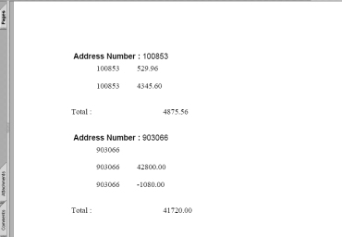](http://www.jdesource.com/business-intelligence/learn-to-addinsert-page-breaks-to-your-rtf-templates/attachment/o1pb/)

If I want to add a page break to the output displayed, the steps will be as

Step 1 :  Create a Form Field Text for Page Break by clicking right mouse click on the blank area as displayed  or by selecting  menu ToolsàCustomizeàcheck in the Forms,it will be displayed as toolbar on the .rtf.

[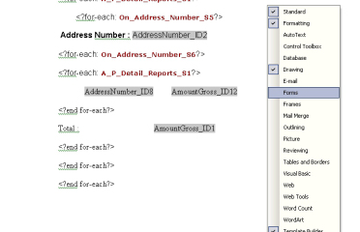](http://www.jdesource.com/business-intelligence/learn-to-addinsert-page-breaks-to-your-rtf-templates/attachment/s1pb/)

Step 2 : Click on the “**ab” (Text Form Field)**,double click on it and type “PageBreak” in the Default Text and write the tag **<?split-by-page-break:?>** by click on “Add Help Text “and add it on “Type your own” as shown:

[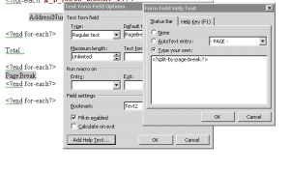](http://www.jdesource.com/business-intelligence/learn-to-addinsert-page-breaks-to-your-rtf-templates/attachment/s2pb/)

<?for-each:**A_P_Detail_Reports_S1**?>

<?for-each:**On_Address_Number_S5**?>

**Address Number :** AddressNumber_ID2

<?for-each:**On_Address_Number_S6**?>

<?for-each:**A_P_Detail_Reports_S1**?>

AddressNumber_ID8         AmountGross_ID12

<?end for-each?>

Total :                                     AmountGross_ID1

<?end for-each?>

PageBreak

<?end for-each?>

<?end for-each?>

The Output will be displayed as :

[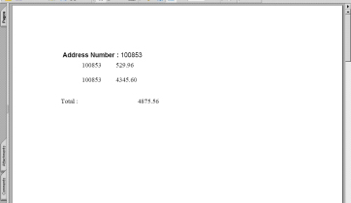](http://www.jdesource.com/business-intelligence/learn-to-addinsert-page-breaks-to-your-rtf-templates/attachment/s3pb/)

[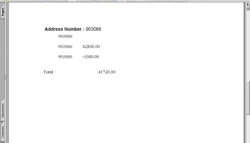](http://www.jdesource.com/business-intelligence/learn-to-addinsert-page-breaks-to-your-rtf-templates/attachment/s4pb/)

Try out on your .rtf and execute the Page Break